TARİH: 01.11.2019
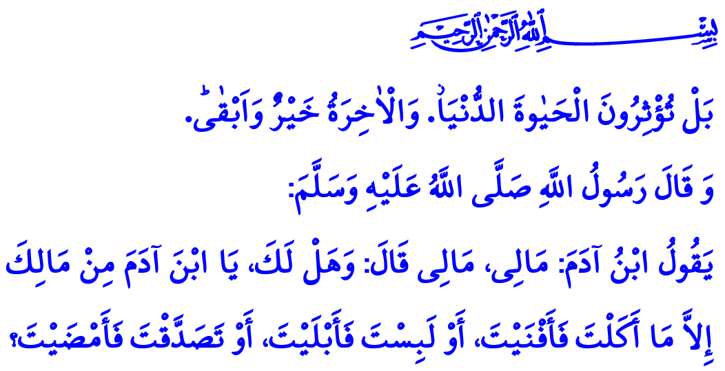 SECULARIZATION: DELIGHT IN THE TEMPORARY LIFE
Honorable Muslims!
The Prophet Muhammad (saw) had made a peace agreement with the people of Bahrain and appointed an ambassador there. After some time, the ambassador returned to Madinah, with a significant amount of goods. Curious, the Ashab al-Kiram gathered around the ambassador and the goods he brought. As the Prophet Muhammad (saw) came out of the masjid, he saw the situation, smiled, and said, “Rejoice and hope for what will please you! By Allah, I am not afraid of your poverty. But I am afraid that you will lead a life of luxury as past nations did, whereupon you will compete with each other for it, as they competed for it, and it will destroy you as it destroyed them.”
Dear Believers!
Islam, the sublime religion, encompasses all aspects of life. Allah's (swt) commandments and prohibitions lead us to the right path in this world, and to the heaven in the Hereafter. Yet despite all this, we get lost in the busyness of worldly affairs, whereby neglecting the life-enhancing principles of Islam. Away we drift from the guidance of the Prophet Muhammad (saw) as our role model, and slowly we lose the influence of Islam in our life that gives meaning to it. We cherish what is transient, lose the balance between the worldly affairs and the affairs relating to the Hereafter, and finally become secularized.
Dear Muslims!
Secularization is when people strive ambitiously for worldly affairs, becoming unaware of Allah (swt) and the Hereafter. It is when they ignore their responsibilities towards Allah (swt), and care about the worldly affairs only. It is when they place religious beliefs, values, and attitudes away from the center of their lives. It is when all they crave, as if they will never die, for are the worldly possessions. Regarding this wrong attitude of people states Allah the Almighty (swt), “Behold, you prefer the life of this world. But the Hereafter is better and more enduring.”
Dear Believers!
The Almighty Allah (swt) has sent us to this temporary life for test and trial. This is not to say that Muslims should completely quit working for their livelihood. It is just that they should not neglect their affairs relating to the life in the Hereafter. It is essential to make legitimate use of the worldly blessings although the main purpose is to work to deserve going to the heaven in the Hereafter. What is important is that Muslims should not be captivated by the means they earn, and that they should use them in accordance with the consent of Allah (swt). In this regard states the Almighty Allah (swt) in the Holy Qur'an, “But seek, with the wealth which Allah has bestowed on you, the Home of the Hereafter, nor forget your portion in this world. But do you good, as Allah has been good to you, and seek not occasions for mischief in the land, for Allah loves not those who do mischief.”
Dear Muslims!
On top of the damages caused by secularization comes the unmindful consumption. While some people are in need of and crave for a piece of food in one corner of the world, other people in another corner push the limits of wasting resources extravagantly. It is unfortunate that today people think happiness rests in consumption. They are under the delusion that they will be happy when they spend more and consume expensive things. However, excessive and immoderate consumption erode our humane and moral values. Many people are lost in the swamp of debt and interest accrued due to unmindful consumption and irresponsible spending. Many families suffer from uneasiness and helplessness. The Prophet Muhammad (saw), however, had warned people from ages ago, “Son of Adam says: 'My wealth, my wealth'. Do you own of your wealth other than what you eat and consume, and what you wear and wear out, or what you give in sadaqah to those who deserve it, and that what you will have in stock for yourself.”
Honorable Believers!
If a delicate balance is struck between the world and the Hereafter, then wastefulness turns into mindful spending, greed and ambition into contentedness, uneasiness into reliance on Allah (swt), abundance into adequateness. Then, more mindful investments should be made in this life and the life in the Hereafter as per their worthiness. So, let us not forget that the life in this world is only as short as a blink of an eye. Let us get prepared for the eternal life in the Herefter. Let us be unpretentious, humble, and moderate in all our affairs and actions.
I would like to conclude this khutbah with the following words of the Almighty Allah (swt), “O People! Certainly the promise of Allah is true. Let not then this present life deceive you, nor let the Chief Deceiver deceive you about Allah.”

Bukhari, Maghazi, 12; Muslim, Zuhd, 6.
A'la, 87/16,17.
Qasas, 28/77.
Muslim, Zuhd, 3.
Fatir 35/5. General Directorate of Religious Services

